Water System
Cross-Connection Survey
Residential
Occupant Name___________________________________________________________________________________
Occupant Address_________________________________________________________________________________

Meter serves: Homes How Many?_______ Buildings How Many?______

- Do you have? (Please Check all that apply):
[ ]Hot Tub | [ ]Swimming Pool | [ ]Jacuzzi
[ ]Waterbed | [ ]Solar System | [ ]Green House
[ ]Underground Sprinkler System | [ ]Darkroom Equipment | [ ]Drip/Soaker/Irrigation System
[ ]Portable Dialysis | [ ]Insecticide Sprayers (That | [ ]Utility sink w/threaded faucet
Machine | attach to garden hose also)
[ ]Wood burning hot water heater | [ ]Ghost pipes (unidentified)
- Do you have bathtub that fills from the bottom? [ ]Yes [ ]No
- Do you have a water softener or any extra water treatment system? [ ]Yes [ ]No
- Do you have an auxiliary water supply on your premises? [ ]Yes [ ]No
- Do you have livestock and use a water trough or water system connected to by public water?
- Is your home or building elevated above your water meter? [ ]Yes [ ]No
- Does a creek, river, or spring water run near or on your property? [ ]Yes [ ]No
- Do you have a booster pump, well pump, or any other type water pump? [ ]Yes [ ]No
- Do you receive irrigation water from a different source? [ ]Yes [ ]No
- Do you have a backflow protection device on your property now? [ ]Yes [ ]No
- Do you have any situation that you are aware of that could create a cross-connection? [ ]Yes [ ]No
- Do you have any other water-using equipment on your property not mentioned above? [ ]Yes [ ]No
If yes, please list:____________________________________________________________________________
____________________________________________ _______________________________________________________
Print Name Phone #(including area code)
Please notify this office if any of the above conditions change.
(Customer Handout)
The Alamo Water System makes every effort to ensure that our customers enjoy a continuous supply of safe drinking water. We appreciate the help of our customers to maintain the quality of our water supply.
Cross Connections can cause the water system to become contaminated. A cross connection is a link with the public water supply and a possible source of contamination. An example of a cross connection would be a garden hose submerged in a source of contamination such as a swimming pool, car radiator or other liquid. If a water main break should occur or if a fire pumper used a fire hydrant while the hose was submerged in a source of contamination, the contaminant could be pulled back into the public water supply. This occurrence, known as backflow, can be prevented.
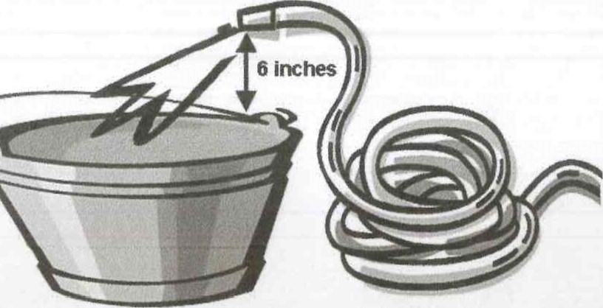
One simple way to stop backflow is by using an air gap. An air gap can be created by arranging your hose so that the end is at least six inches above the top rim of the container it is being used to fill. This air gap will prevent the contaminant from being siphoned into the water supply.
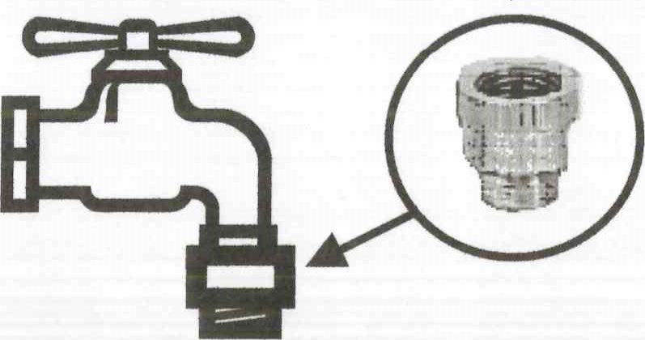
Another method of preventing backflow with a garden hose is using a device known as a vacuum breaker. Vacuum breakers are inexpensive devices that can be screwed onto your outside faucet. These devices will prevent contaminants from being siphoned back into your plumbing and the public water system.
More hazardous cross connections or cross connections created with permanently installed plumbing may require more sophisticated devices known as reduced pressure backflow preventers. These devices are much more complicated and must be tested annually by certified testers.
For more information on preventing cross connections and protecting our water supply, contact the Alamo Water System at 731-696-4515.
REMEMBER: Never submerge your garden hose in anything you would not want to drink!

